|  |
| --- |
| **iKidsTV** |
| Quiz Interface |
|  |
|  |
| Version: 1.0 |
|  |

Project ID No.: 2008000264

Version 1.4.1GA

Best Shore Application Services

China Center

Prepared by: Zhang, Wei & Li, JingJing

Best Shore Application Services

China Center

# Notice

Document Revision History

| Ver. No. | Ver. Date | Prepared By | Reviewed By | Approved By | Affected Section & Summary of Change |
| --- | --- | --- | --- | --- | --- |
| 1.0 | 2014-2-12 | Zhang Wei | Wang Kun |  | Draft |
| 1.1 | 2014-2-13 | Zhang Wei |  |  | Revised by Wang Kun’s comments  Add API for episode to check quiz existence  Revise some error in json format |
| 1.2 | 2014-2-21 | Zhang Wei |  |  | Remove age parameter |
|  |  |  |  |  |  |
|  |  |  |  |  |  |
|  |  |  |  |  |  |

# Table of Contents

Notice 3

Document Revision History 3

Table of Contents 4

List of Figures 5

List of Tables 6

Preface 7

About this Guide 7

Audience 7

Conventions 7

Abbreviations 7

1 Check Quiz Existence for Season 9

1.1 Interface url 9

1.2 Error Response 9

1.3 Success Response 9

2 Check Quiz Existence for Episode 9

2.1 Interface url 10

2.2 Error Response 10

2.3 Success Response 10

3 Query Quiz for Episode 10

3.1 Interface url 10

3.2 Error Response 11

3.3 Success Response 11

3.3.1 MultiChoice1 11

3.3.2 MultiChoice2 12

3.3.3 MultiChoice3 13

3.3.4 Matching 14

3.3.5 Bingo 15

3.3.6 Sequence 16

3.3.7 CatchItWord 17

3.3.8 CatchItSentence 18

3.3.9 WordSearch 19

3.3.10 FindDifference 20

3.3.11 StoryTelling 21

# List of Figures

**No table of figures entries found.**

# List of Tables

**No table of figures entries found.**

# Preface

## About this Guide

This guide gives a detailed description on the interface between app client and quiz server.

## Audience

This document aims to be used by developer and architecture designer.

References:

## Conventions

|  |  |
| --- | --- |
| Courier Text | It is used for filenames and their contents, computer inputs or outputs, program codes, and so on. |
| Italicized text | It is used for labels, parameters, emphasized text, and replaceable text. |
| bold text | It is used to indicate navigation options in the interfaces; for example, the text appearing in buttons and menu items. |
| <angle brackets> | Indicates generic variable names that must be substituted by real values or strings. |

## Abbreviations

|  |  |
| --- | --- |
| App client | iOS and Android client |

# Check Quiz Existence for Season

## Interface url

This interface is used to tell client whether the episode has related episode.

/checkQuizExistence.do?seasonId=${seasonId}&device=${device}&level=${level}&version=${version}

|  |  |  |
| --- | --- | --- |
| Parameter Name | Required | Description |
| seasonId | YES | The unique season id |
| device | YES | The device type [Android,IPhone,IPad] |
| level | YES | The level to filter quiz for user[a1,a2,a3,b1,b2,b3,c1,c2,c3] |
| version | YES | The client version |

## Error Response

{message:””,code=””}

|  |  |
| --- | --- |
| Error Code | Description |
| 100000 | System Error |
| 100001 | This client version will never be supported, please upgrade this client first |
| 200000 | Illegal parameter |

## Success Response

{code=”0”,result:[{“00868473-89df-4f84-8b2d-77ff04f18899”:true}, {“01e3b008-3141-4e82-afd6-7a11448f1357”:false}, {“05fda1d6-9264-4c4c-93dc-8b8dc0de8d4d”:false}]}

# Check Quiz Existence for Episode

## Interface url

This interface is used to tell client whether the episode has related episode.

/checkQuizExistence.do?episodeIds=${episodeIds}&device=${device}&level=${level}&version=${version}

|  |  |  |
| --- | --- | --- |
| Parameter Name | Required | Description |
| episodeIds | YES | The comma split episode ids |
| device | YES | The device type [Android,IPhone,IPad] |
| level | YES | The level to filter quiz for user[a1,a2,a3,b1,b2,b3,c1,c2,c3] |
| version | YES | The client version |

## Error Response

{message:””,code=””}

|  |  |
| --- | --- |
| Error Code | Description |
| 100000 | System Error |
| 100001 | This client version will never be supported, please upgrade this client first |
| 200000 | Illegal parameter |

## Success Response

{code=”0”, result:[{“00868473-89df-4f84-8b2d-77ff04f18899”:true}, {“01e3b008-3141-4e82-afd6-7a11448f1357”:false}, {“05fda1d6-9264-4c4c-93dc-8b8dc0de8d4d”:false}]}

# Query Quiz for Episode

## Interface url

This interface is used to provide all of quiz metadata to client.

/queryQuiz.do?episodeId=${episodeId}&device=${device}&level=${level}&version=${version}

|  |  |  |
| --- | --- | --- |
| Parameter Name | Required | Description |
| episodeId | YES | The unique episode id |
| device | YES | The device type [Android,IPhone,IPad] |
| level | YES | The level to filter quiz for user |
| version | YES | The client version |

## Error Response

{message:””,code=””}

|  |  |
| --- | --- |
| Error Code | Description |
| 100000 | System Error |
| 100001 | This client version will never be supported, please upgrade this client first |
| 200000 | Illegal parameter |

## Success Response

Type Enumeration:

MultiChoice1

MultiChoice2,

MultiChoice3

Matching

Bingo

Sequence

CatchItWord

CatchItSentence

WordSearch

FindDifference

StoryTelling

Record: All of records, pictures are http url

{code=”0”, result:[{type:”MultiChoice1”,…},{type:”MultiChoice2”,…},…]}

### MultiChoice1

{type:”MultiChoice1”, id:”1”,title:””,titleRecord:””,word1:””,record1:””,word2:””,record2:””,word3:””,record3:””}

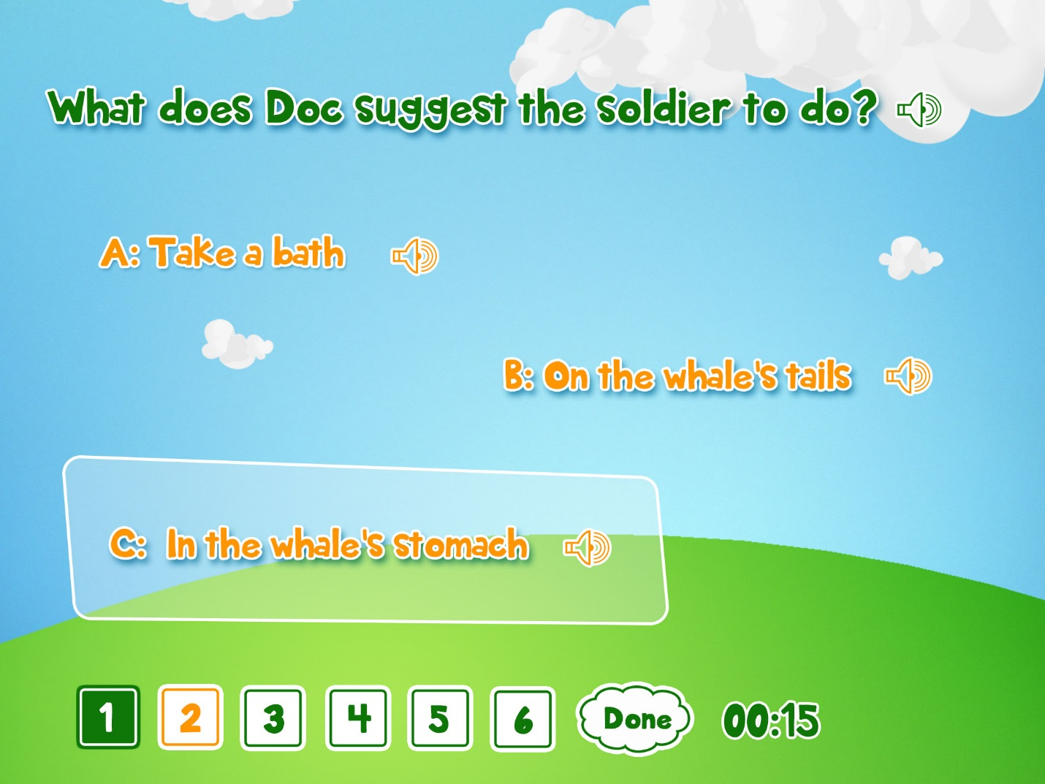

### MultiChoice2

{type:”MultiChoice2”, id:”2”,title:””,titleRecord:””,picture1:””,picture2:””,picture3:””,answer1:”true”,answer2:”false”,answer3:”false”}

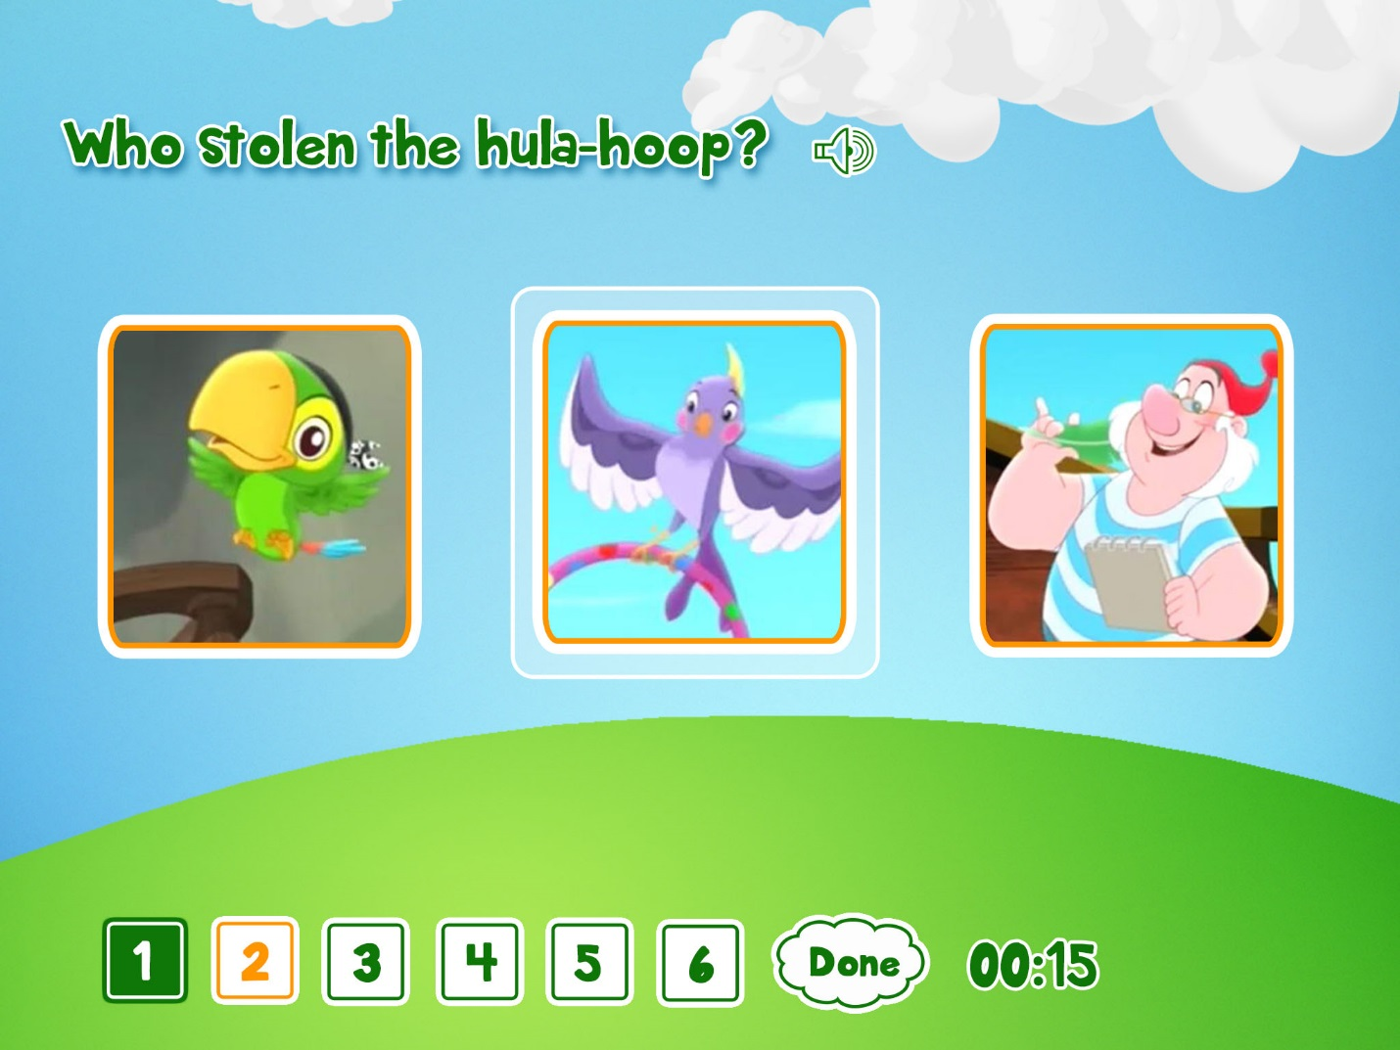

### MultiChoice3

{type:”MultiChoice3”,id:”3”,title:””,titleRecord:””, titlePicture:””,word1:””,record1:””,word2:””,record2:””,word3:””,record3:””,answer1:”true”,answer2:”false”,answer3:”false”}

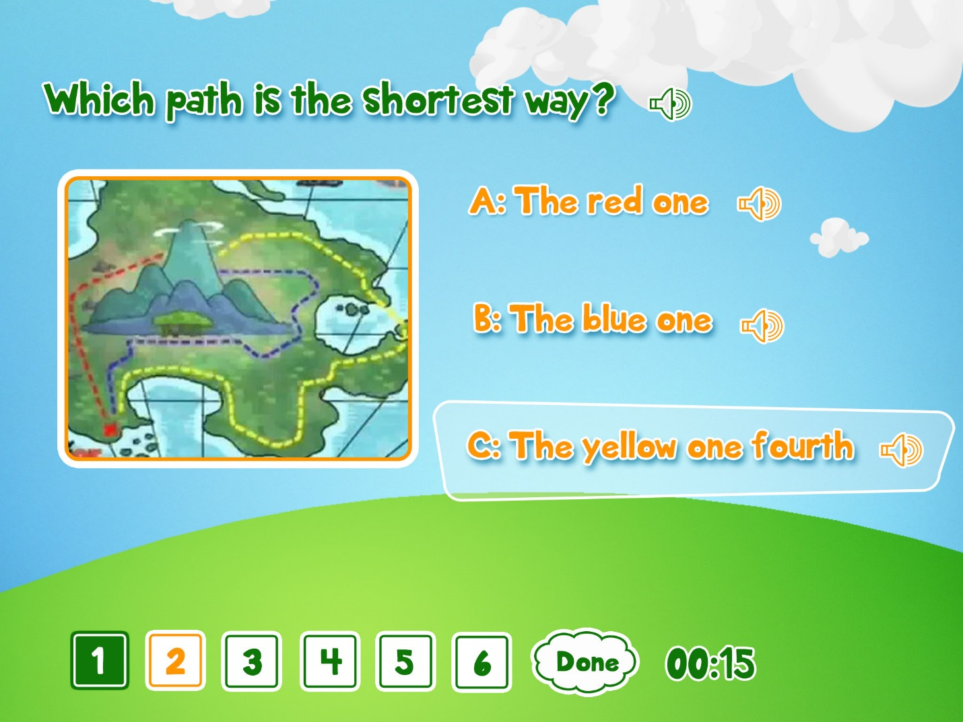

### Matching

{type:”Matching”,id:”4”,word1:””,picture1:””,word2:””,picutre2:””,word3:””,picutre3:””,answer1:”true”,answer2:”false”,answer3:”false”}

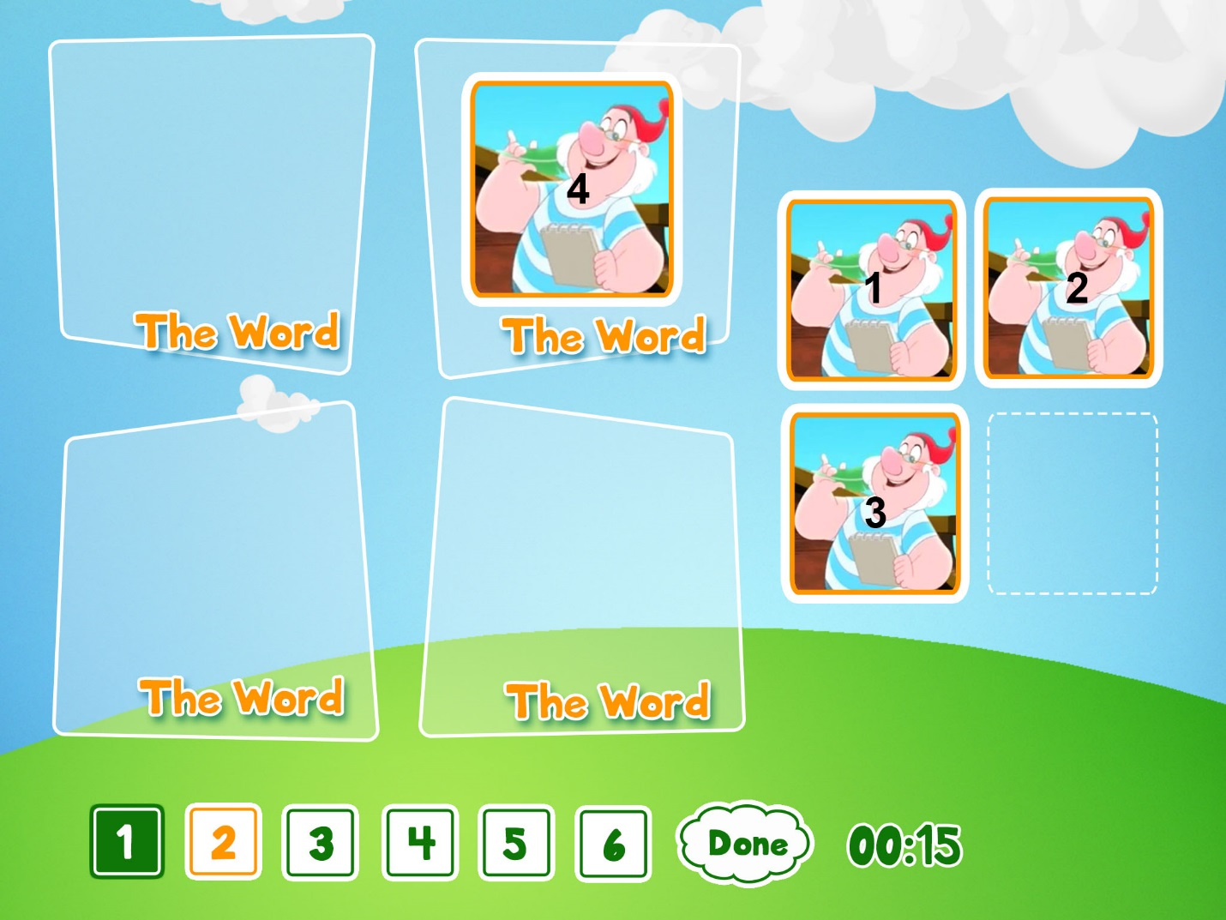

### Bingo

{type:”Bingo”,id:”5”,word1:””,record1:””,word2:””,record2:””,word3:””,record3:””,… word16:””,record16:””}

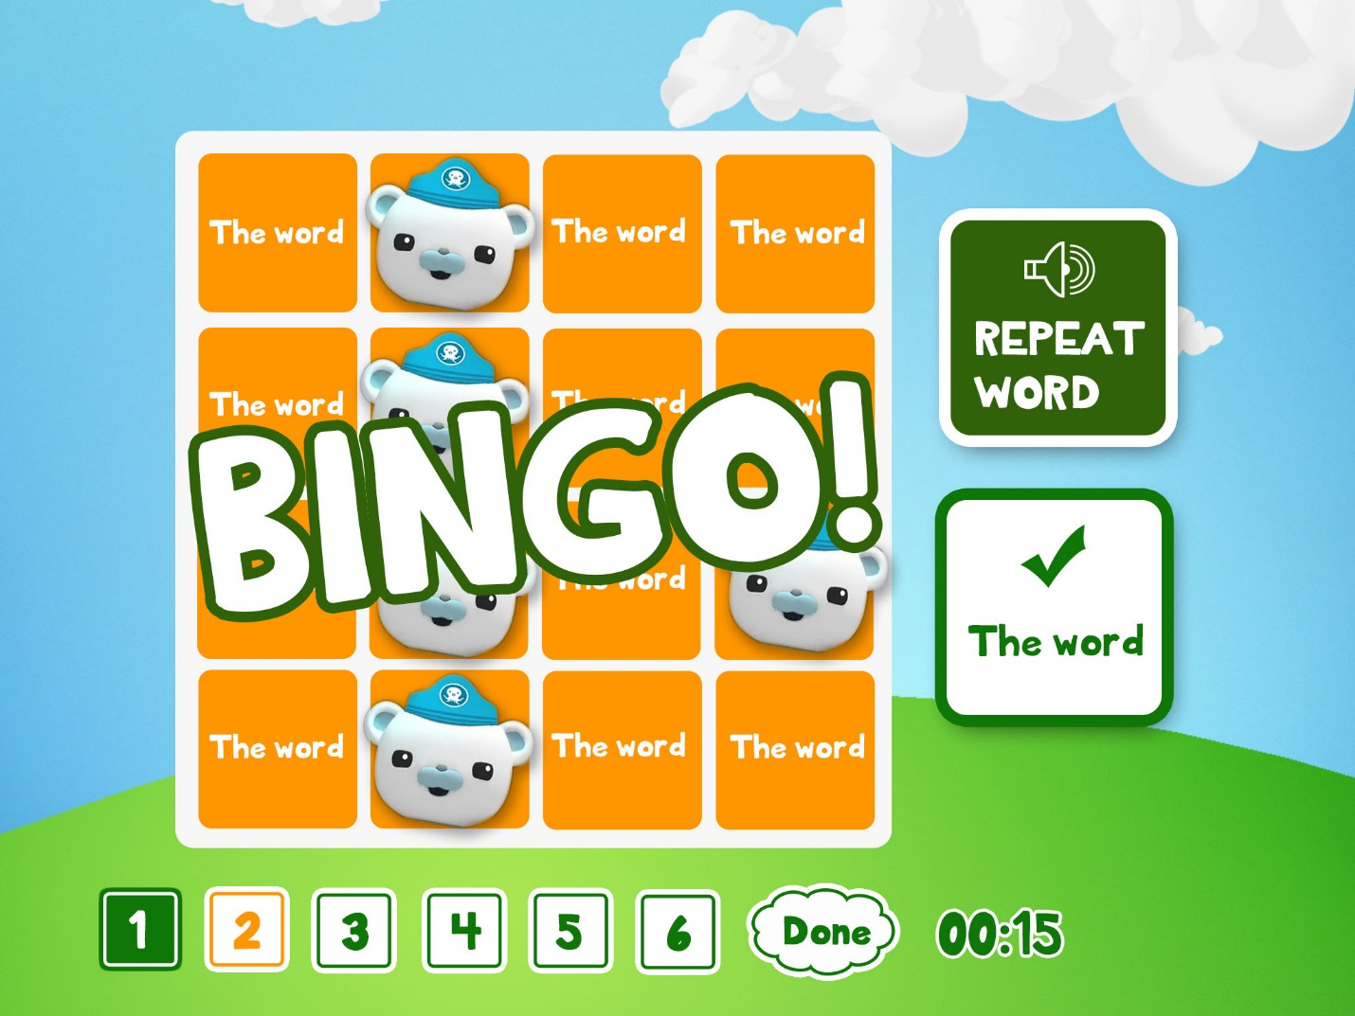

### Sequence

{type:”Sequence”,id:”5”,word1:””,picture1:””,record1:””,word2:””,picture2:””,record2:””,word3:””,picture3:””,record3:””, word16:””,picture4:””,record16:””}

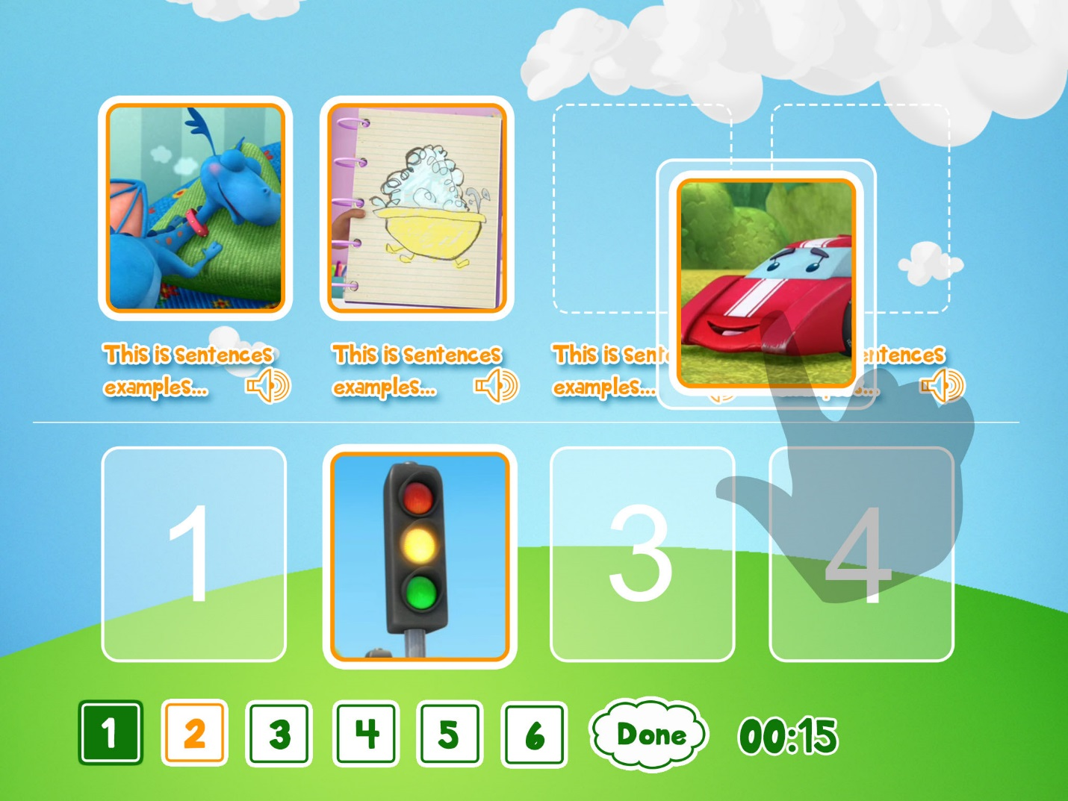

### CatchItWord

{type:”CatchItWord”,id:”5”,word1:””,word2:””,word3:””,word4:””,word5:””,word6:””,word7:””,word8:””,answer1:true,answer2:true,answer3:true,answer4:true,answer5:false,answer6:false,answer7:false,answer8:false}

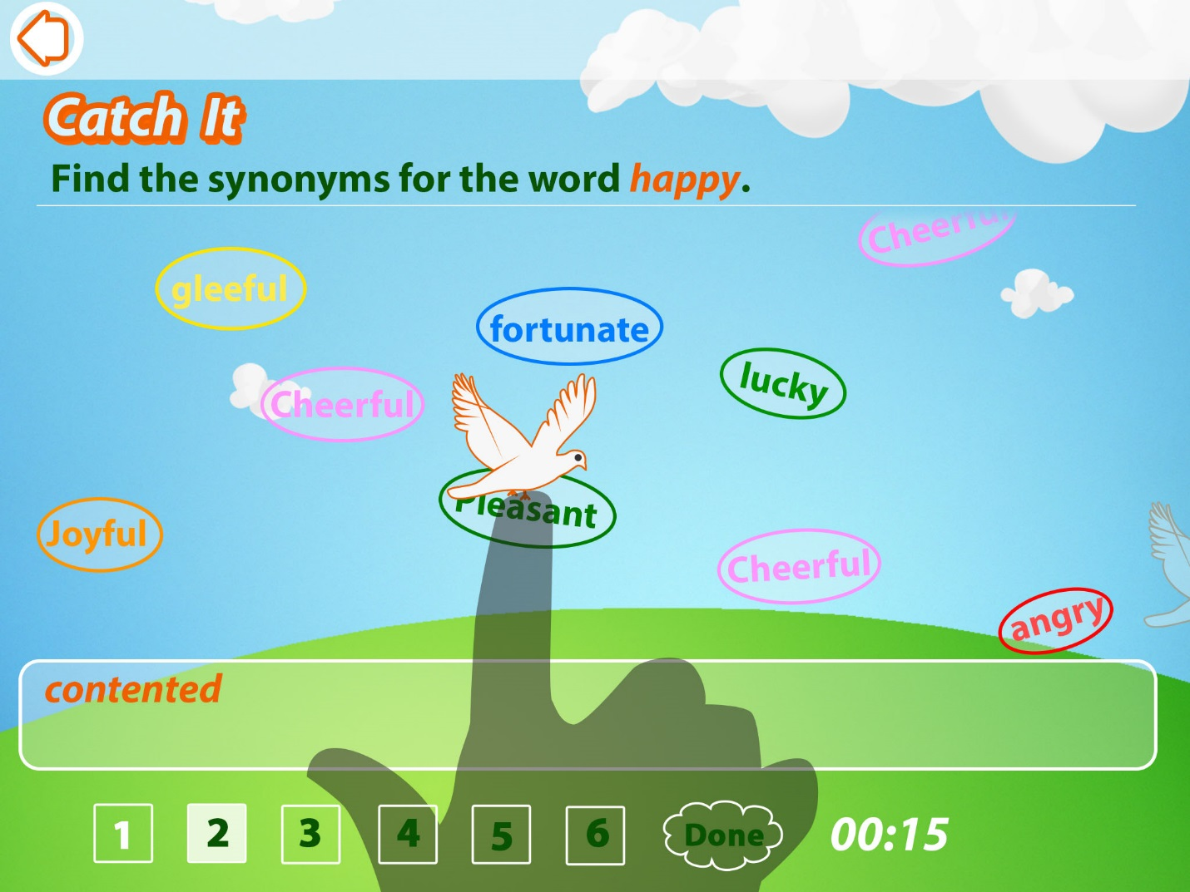

### CatchItSentence

{type:”CatchItSentence”,id:”5”,word1:””,word2:””,word3:””,word4:””,word5:””,word6:””,word7:””,word8:””,answer1:true,answer2:true,answer3:true,answer4:true,answer5:false,answer6:false,answer7:false,answer8:false}

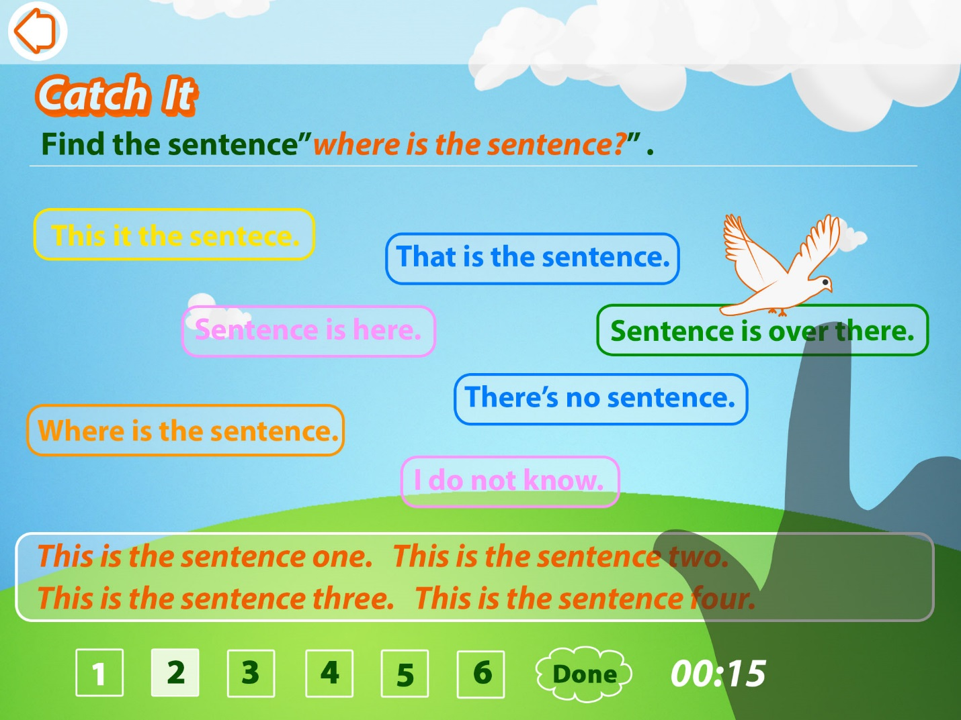

### WordSearch

{type:”WordSearch”,id:”5”,word1:””,word2:””,word3:””,word4:””,word5:””}

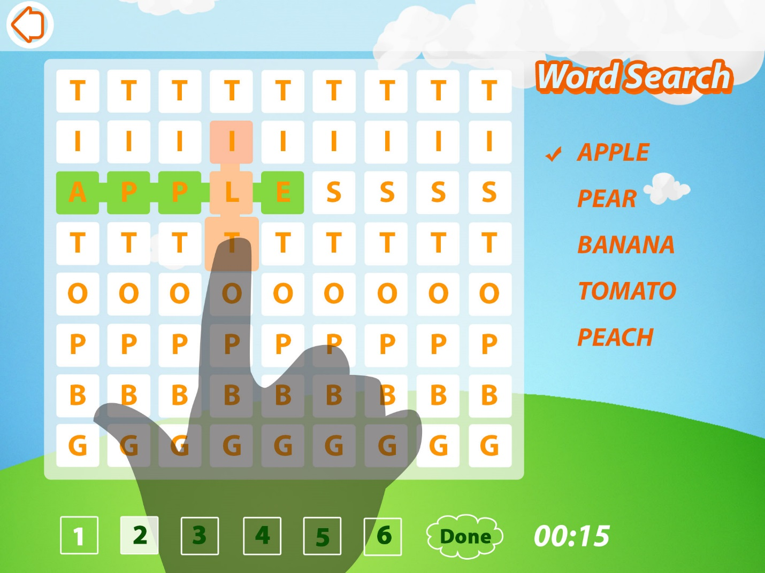

### FindDifference

{type:”FindDifference”,id:”5”,picture1:””,picture2:””,coordinates:[{x:15,y:15},{x:20,y:20}]}

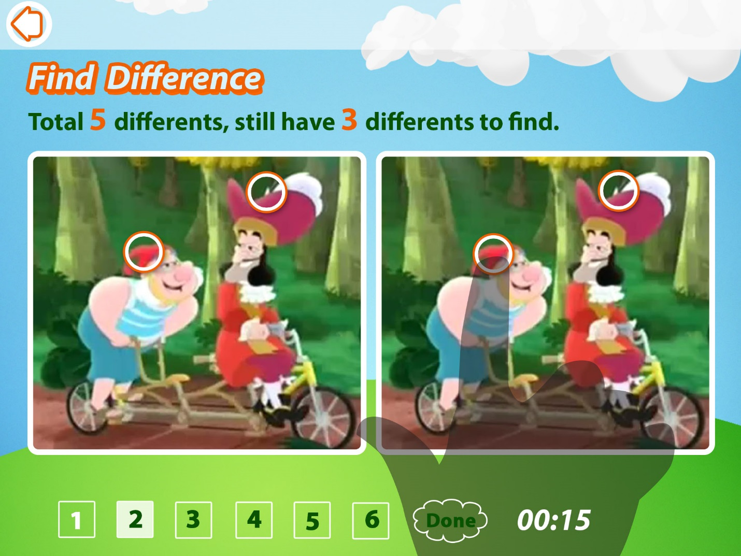

### StoryTelling

{type:”StoryTelling”,id:”5”,backgroundPicture:””,picture1:””,picture2:””,picture3:””,picture4:”” }

